**Testing**:

Testing is to validate the software/application/module/product is behaving in expected behaviour by meeting all the business requirements.

**Manual Testing:**

QA/Manual Testers will perform manual testing and raise defects/bugs without using any automation tools.

**Automation Tester:**

SDET team will be performing the automation testing by running the scripts using Automation Tools.

**Environments:**

**Unit Testing**: Developer Environment

**SIT/System Testing**: Tester Environment

**UAT**: Tester Environment

**Production** (Alpha): Testing Environment

**Beta**: Production Environment.

**->Unit Testing:** will be performed by the developer in unit testing(development) Environment

Testing the small functionality or a piece of the code written by a developer in his/her machine to validate functionality is working fine is called Unit Testing.

->**System Testing**: will be performed by the tester in testing environment.

Testing the critical functionalities that validates the complete/fully integrated flow in an application/product/module. Testers will validate the end-to-end flow.

**Types of System Testing:**

->Functional Testing:

->Usability Testing

->Regression Testing

->Load Testing

->Migration Testing

**Integration Testing**: Testing the software/application/product when it is integrated with another module. Here testers will be performing the **Integration Testing.**

**Acceptance Testing:** Testing Technique performed whether the software has met the business requirement specifications. The main objective is to evaluate the system compliance with the business requirements and verify it has met the Acceptance Criteria Specified to deliver to the end users.

**Black Box Testing:** We will test the functionality of the application /module/flow in an application without having knowledge of internal code, implementation details and internal paths. It is mainly focusing on input and output of software applications based on software requirements and specifications.

**(Equivalence Class Partitions) ECP: 1 Rs to 1cr**

P1 ->1rs to 10 L -> 50, 5000, 23730,345000, 5,876 (10 different set of test data), 1.5465,6

P2->10L to 20 L->10 different set of test data

P3->30L to 40 L->10 different set of test data

--

--

P10->90L to 1 CR->10 different set of test data

**Boundary Value Analysis:**

P1 ->1rs to 10 L -> 0.99,1,1.01 99,999 , 99,99.912 , 10,00,000.5, 10,0001

P2->10L to 20 L->10 different set of test data

P3->30L to 40 L->10 different set of test data

--

--

P10->90L to 1 CR->10 different set of test data

**White Box Testing:** Testing the functionality of a module or a application or a product by knowing/aware of internal logic /code is called white box testing. Testers will have limited knowledge. Testing will be performed by Dev team.

Type Of **Black Box Testing:**

**->**Functional Testing

->Non-Functional Testing

->Regression Testing

Types of **White Box Testing:**

->**path** testing

Example :

if(price>10,000&&price<25000)

{

discount 12%

}

else if(price<10,000)

{

discount 7%

}

else if(price>25,000&&price<50000)

{

discount 18%

}

->**loop** Testing

For(int price =1 ;price < 100,000;price++){

Discount 15 %;

}

->**Condition** Testing

Time Duration for displaying the banner.

--------------------------------------------------------------------------------------

**Smoke Testing:**

Testing critical functionalities of an application when application is at initial phase. Here Application is not stable, and it is not ready to be used by the end user.

**Sanity Testing:** Testing the new added functionality in an application or testing the build whether it is successful or not is called sanity Testing

**Regression Testing**: When a new functionality is added, Testing the entire module or entire flow in an application in order to make sure that newly added functionality is not going to affect the existing flow/ existing modules in an application.

**Re-Testing**: Testing the functionality/flow in a module or application one more time after defect is fixed by the development team is called Re-Testing. Here we will Re-test this repeatedly until defect is fixed by the Dev Team.

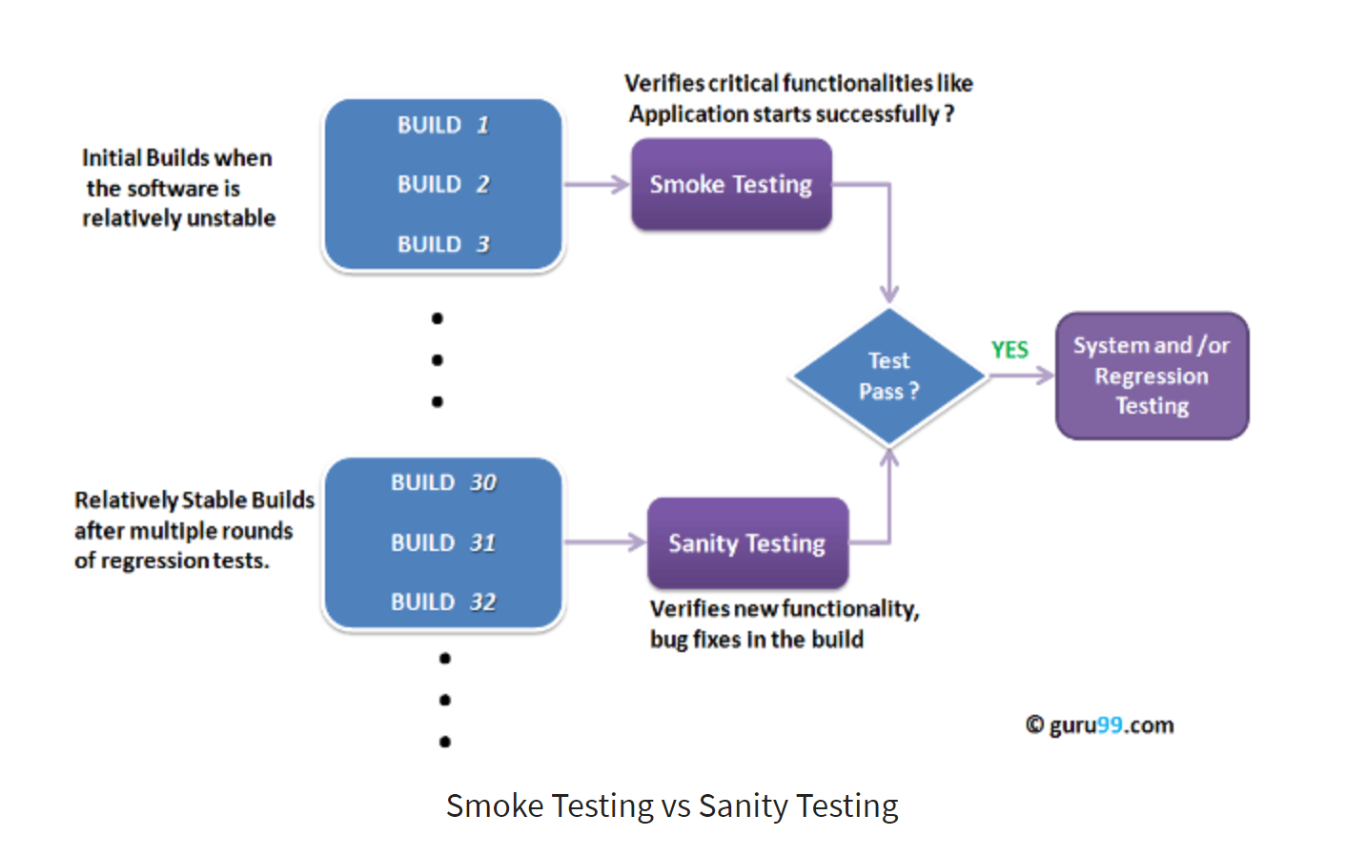

**------------------------------------------------------------------------------------------------------------------**

**Defect/Bug:** Any deviation observed from the expected behaviour is called defect/bug.

Only Testers will be raising the defect/bug.

Defect will never raise by dev team, they may ask us to raise the defect.

->JIRA, HP ALM are the generally most used defect management tools.

**Steps need to be followed when raising a bug/defect?**

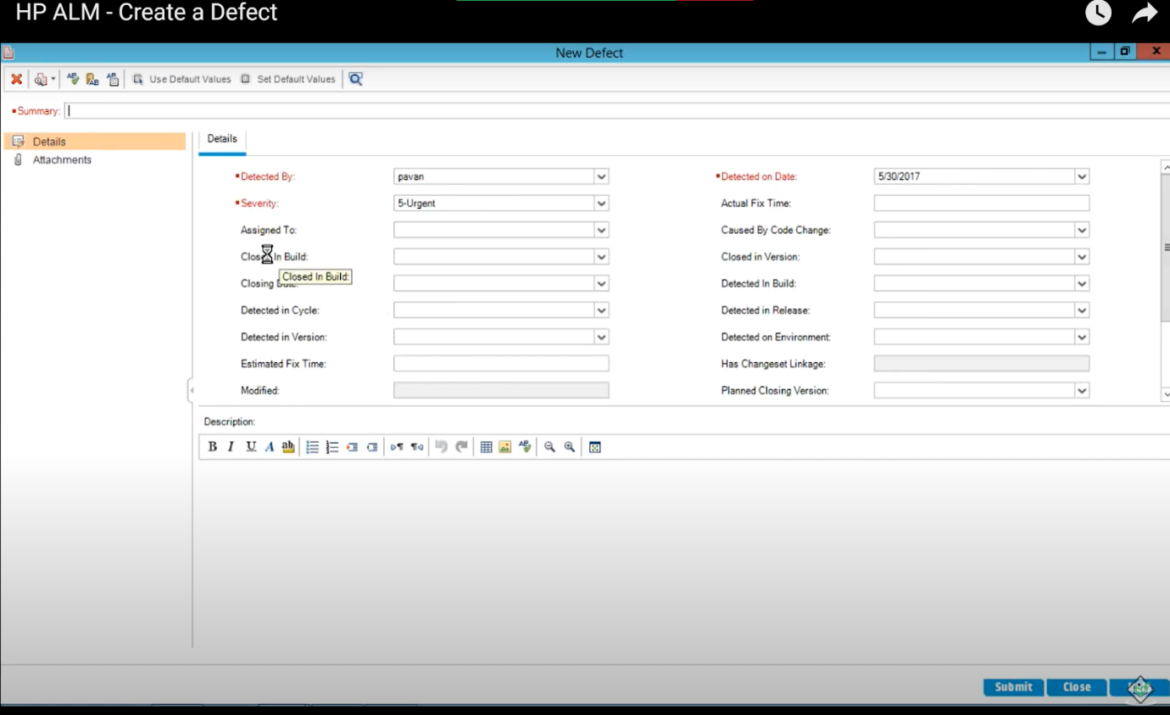

**Summary**: SIT US 15421: when customer added a product to cart, In the add to cart page the “place order” button is disabled in SIT environment.

**Severity**: It is based on how much/critical functionality is getting effected.

Critical, medium, low, high

**Priority**: It is based on How soon the defect need to be fixed by development team

High, low, medium, urgent.

Assigned To: Developer Name

Closed in Build: Flipkart -April Release /

Closing Build: SIT

Detected in Cycle: April 2021

Detected in Version: V11.3

EFT: 8 hours

**Description**:

**Steps to Reproduce**:

1. Login into application with valid credentials.
2. Navigate to mobiles section/module and click on “Samsung” link.
3. Click on individual mobile on mobile list page
4. Click on add to cart on product details page
5. “Place order” button is disabled on add to cart page.

**Test data:**

[SAMSUNG Galaxy M32 (Black, 64 GB)](https://www.flipkart.com/samsung-galaxy-m32-black-64-gb/p/itm772345beff2ad?pid=MOBG4NZWVVESH2BK&lid=LSTMOBG4NZWVVESH2BKAOMLSH&marketplace=FLIPKART)

**Expected Result/behaviour/functionality:** Place order button should be enabled on add to cart page allowing the end user/customer to place an order.

**Actual Result/ behaviour/functionality:** Place order button is disabled on add to cart page . End user/customer is not able to place an order. This is affecting the business.

Please find attachments for reference.

----------------------------------------------------------------------------------------

**Defect/Bug Life Cycle:**

**We need to explain the how the status of the defect changes .**

**New ->Assigned ->In Progress->Fixed->(R4R) Ready for Re-Test->Closed (If defect is resolved)**

**New ->Assigned ->In Progress->Fixed->(R4R)->Ready for Re-Test->Re-Open (if defect is not resolved)**

**--------------------------------------------------HP ALM Stages of a Defect-------------------------------------------**

**New:** When created

**Assigned:** when assigned to developer

**In progress:** When Developer starts working on it

**Fixed:** When Developer provided solution (code changes had been made/included by developer) but not yet pushed/deployed the code changes to testing Environment.

**Ready for Retest (R4R):** When code changes are deployed to testing environment and defect is ready to Re-test

**Pending for clarification:** When developer need more information regarding the defect.

**Reject:** When developer rejected**.**

**Issue to watch for:** Testing team is monitoring this defect**.**

**Deferred:** It is Defect which is accepted by development Team, and it will be fixed by dev team in next release /Iteration /Sprint. When dev team is not written any code to implement functionality.

Marking the defect as deferred as dev team is going to implement this functionality in next release (Oct 2021 Release cycle)

**Closed:** When QA team re-test the defect and found that issue is resolved.

**Re-Open**: When QA team re-test the defect and found that issue is **NOT** resolved.

**Blocked**: When One defect depends on another defect

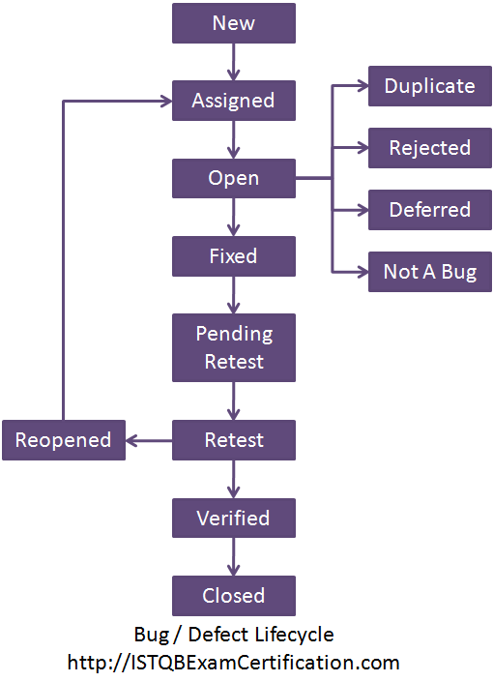

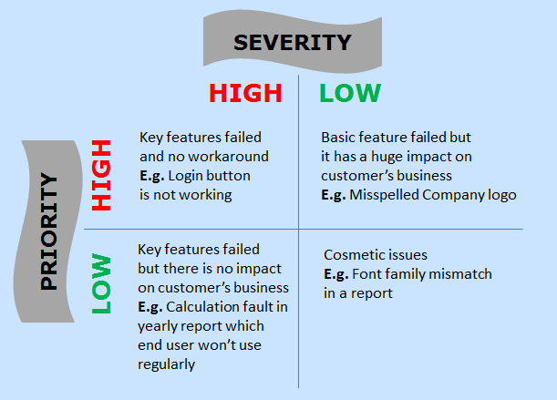

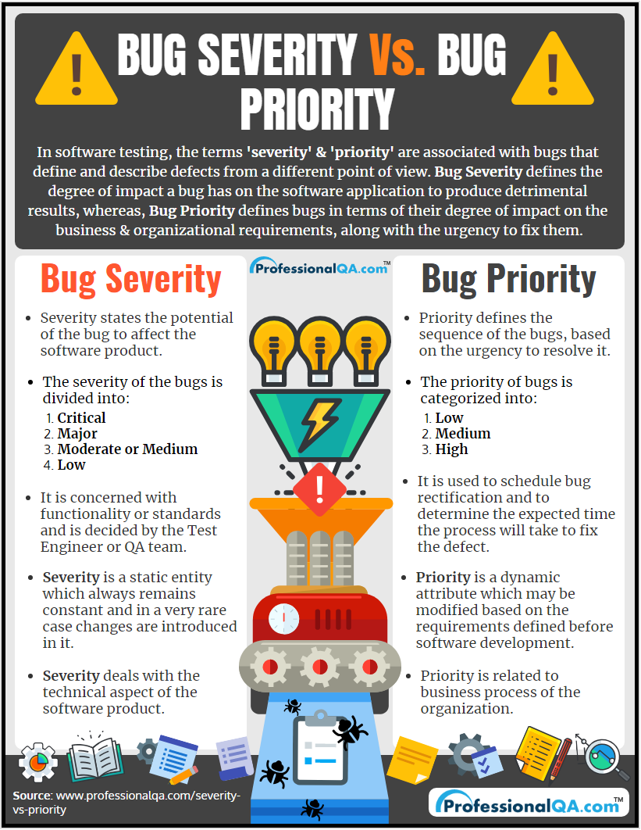

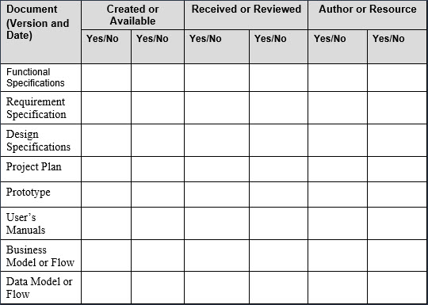

Software test plan :

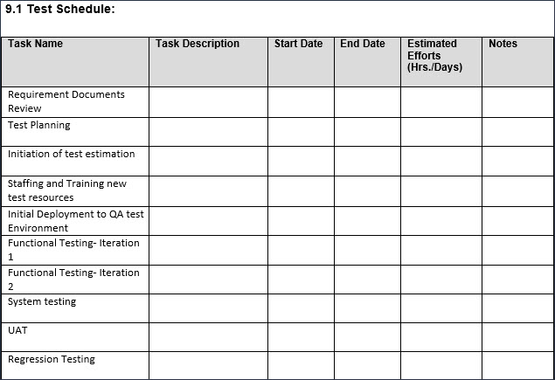

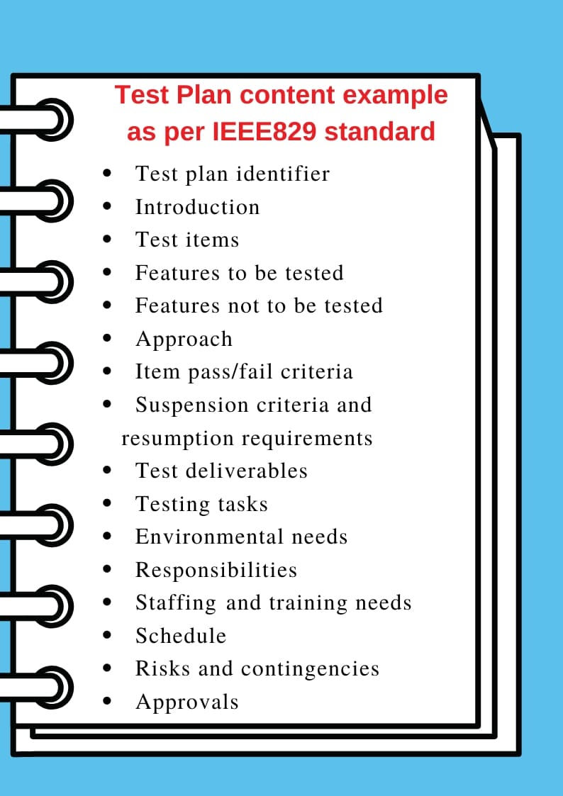

Software Development Life Cycle (SDLC)

Software Test Life Cycle (STLC)

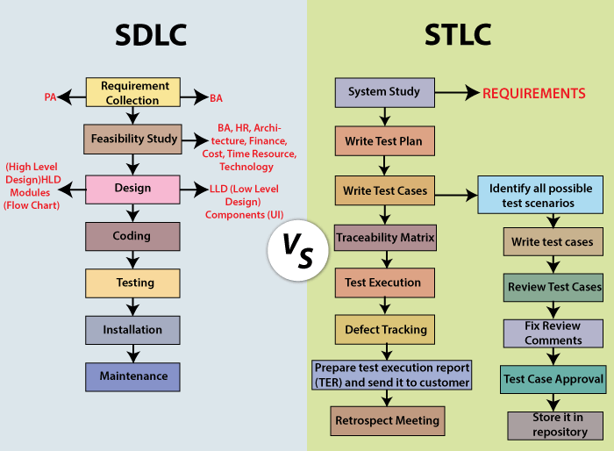

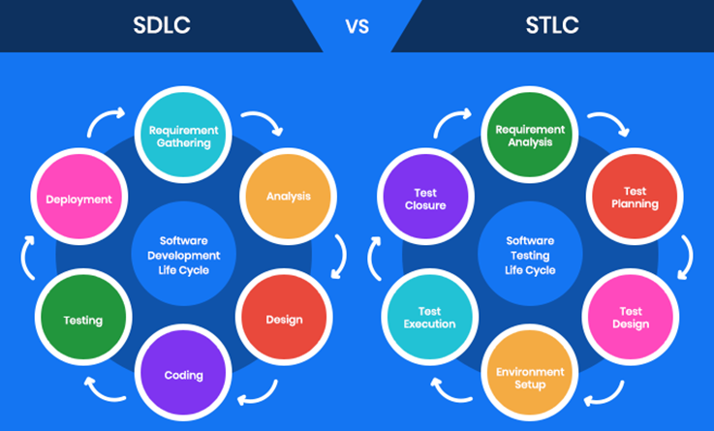

HP ALM Screen Shots:

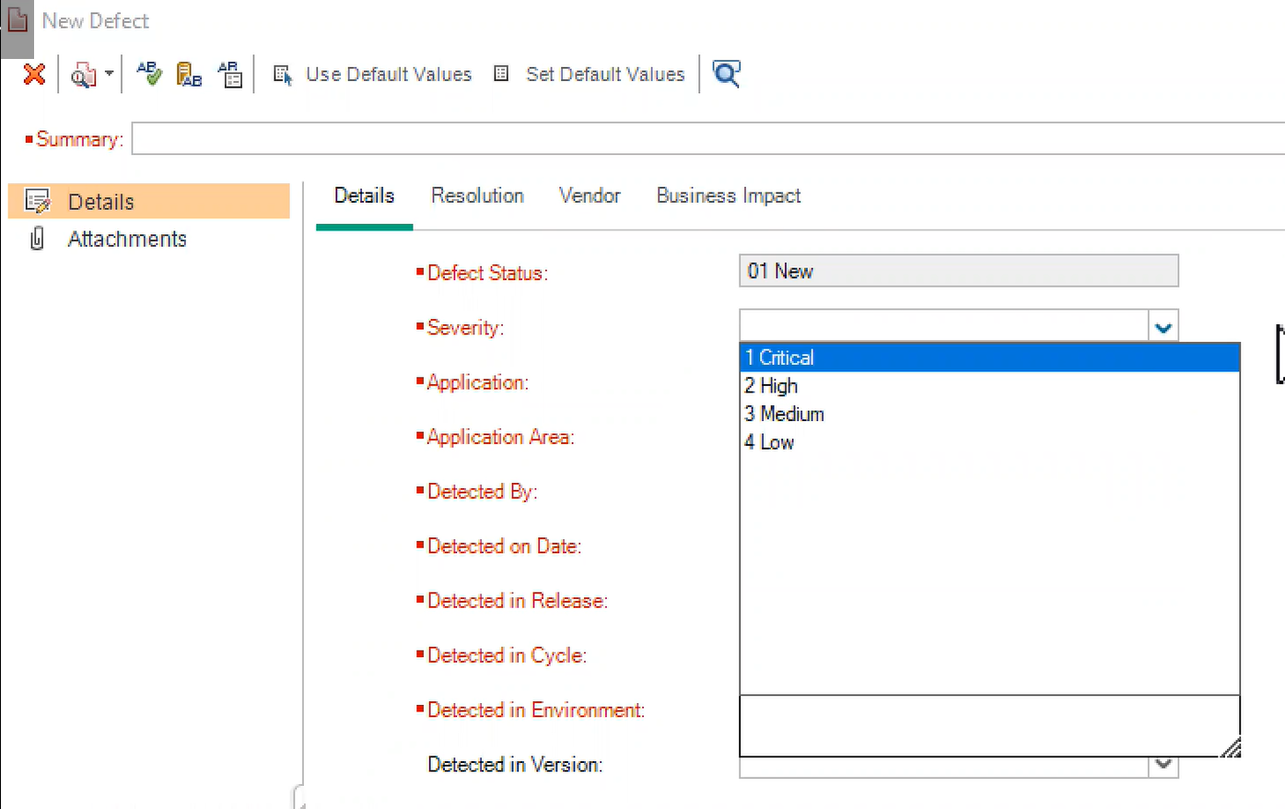

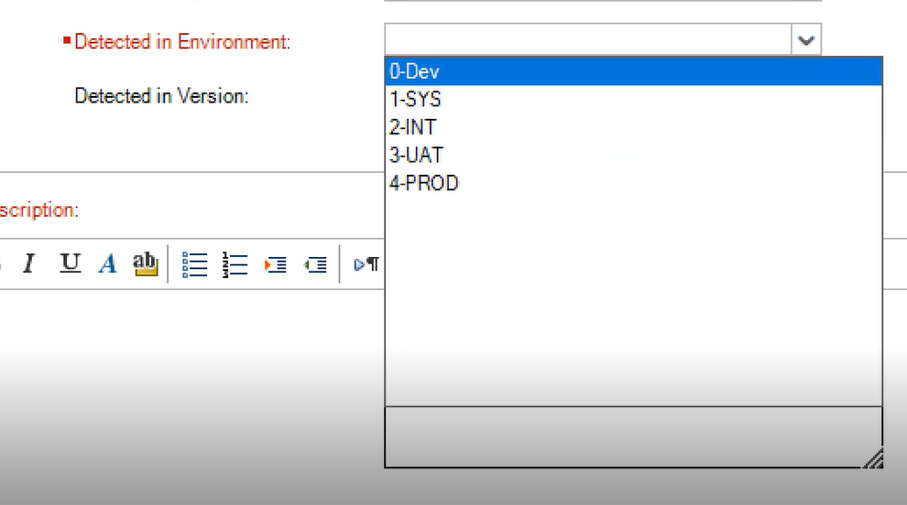

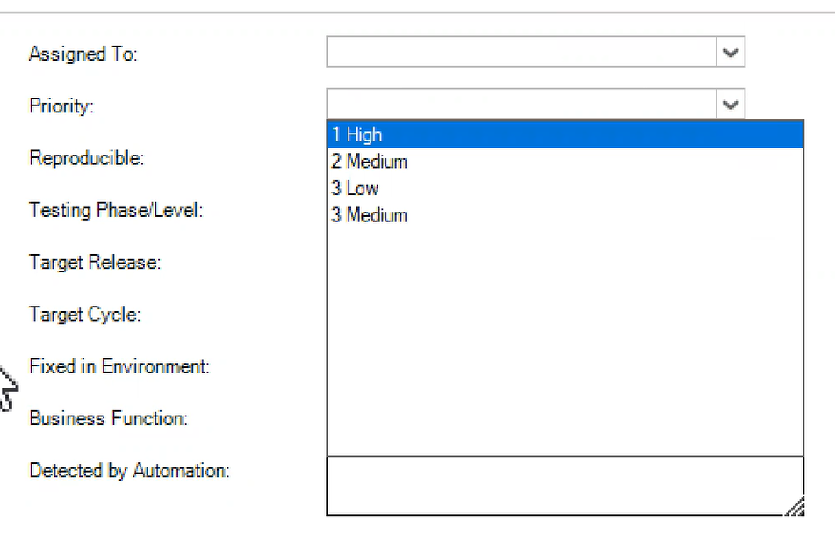

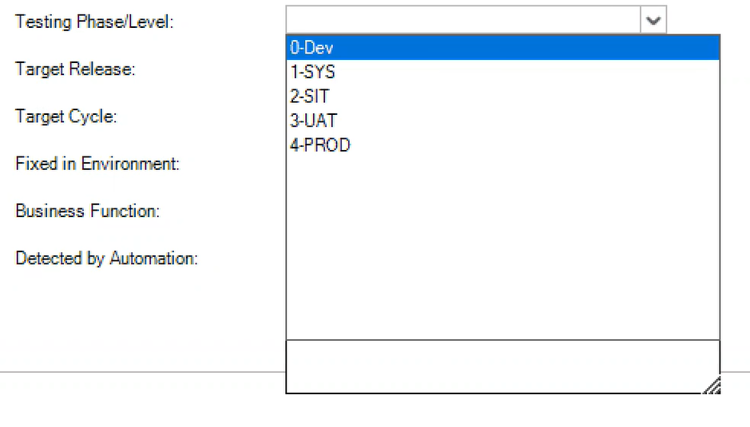

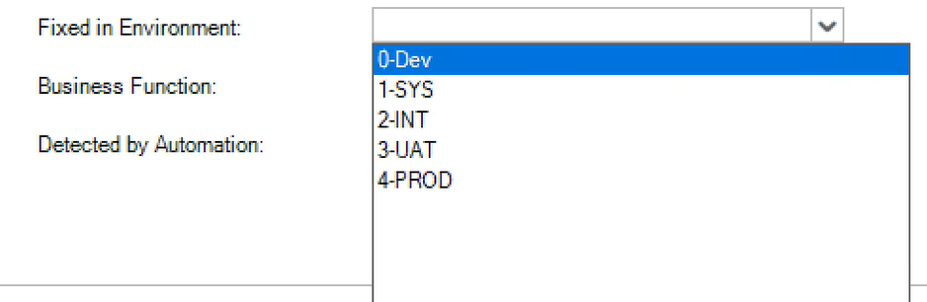

User Story: FLPK6512

CART PAGE: Information displayed in Add to cart Page when product are added to add to cart page

**Acceptance Criteria:**

1.customer should be able to view Products name and price information added to the cart

2.customer should be able to view Product Delivery estimation and replacement policy separately for every product.

3.customer should be able to view Address information in Deliver to Address Drop Down

4.For Mobiles and televisions, customer have a feasibility to increase or decrease the qty. when Qty is increased or decreased alert pop up appears informing the users that the qty has updated.

5.For Mobiles and televisions, customer have a feasibility to select SAVE FOR LATER and REMOVE options.

6. Price Details module at the right side of the add to cart page

7. customer should be able to view following information in price details module

->price (QTY items)

->Discount

->Buy more & save more

->Delivery Charges

->Total Amount

8.customer should be able to view amount saved in green font

L**et us assume this is a 8 point User Story:**

**Let us assume ours is a 3 week Sprint .**

**1 Developer: per week = 5 days = 5*8=40 hrs per week . Per 3 weeks 40* 3 =120 hrs**

**1 Tester : per week = 5 days ==5*8= 40 hrs per week . Per 3 weeks 40 * 3 =120 hrs**

**Let us assume 3 developers and 3 testers are there in project .**

**Total = 360+360 = 720 hrs**

1 point = 8 hours or 4 hours. Let us consider 8 hrs.

8 point = 8*8=64 hrs.

User story points are taken by considering Fibonacci series: 0, 1, 1, 2 ,3, 5, 8, 13, 21

**Dev Team:**

5 points= 5 *8 = 40 hrs =40/8=5 days

**Testing / QA Team:**

3 points: 3 *8 =24 hrs = 24/8=3 days

Maximum occupancy: 50 to 60 % of their time.

Test cases : +ve and -ve test cases are shared in excel

------------------------------------------------------------------------------------

Order by which software/product is released to market:

**Unit Testing -> SIT (System Integration) Testing -> UAT(User Acceptance) Testing ->Alpha Testing ->Beta Testing->Release the product to the Production and then it will be released to live.**

**Alpha Testing**: performed by **skilled testers / developers at the developer’s site** after acceptance testing. It ensures to identify every type of issue which was not identified before in previous rounds of testing.

**Beta Testing**: Performed by group of users who are not a part of organization (Third party users). It is performed to validate whether the application is satisfying customer needs and requirements completely. Here all the business scenarios will be validated and decides whether to release the product or not.

**Test Strategy**: High level document

usually developed by project manager. It captures the approach on how we are going to test the product and satisfy business customer requirements. It contains the wire frames and business flow in an application.

**Test plan:** Testers will take Test Strategy and start writing test plan. Prepared by test lead/manager.

Focus on what to test and what not to test and what is our scope of testing. When to test, what to test and how to test. It contains in which tools we are using for automation and what is framework that is followed and where is the test data maintained. It should always keep up to date. Exit criteria is included and risks included are also mentioned in this test plan document.

**Compatibility Testing**: Testing the functionality in different operating systems like windows 10, windows 8, windows 7, Mac OS, IOS 14, IOS 12...etc, Android version 11, 10,9 and different browsers like chrome, IE, Safari, Edge ...etc.

**Negative Testing:** we will perform negative testing to know how application behaves when invalid values are given by end customer / end user.

**ATM:** withdraw 500 Rs from ATM

Pre-condition / pre- requisite:

1.valid card should be taken.

Test cases:

1.Card should be detected.

2.Testing the pin of ATM card with invalid pin at first time (Negative)

3. Testing the pin of ATM card with invalid pin at second time (Negative)

4. Testing the pin of ATM card with invalid pin at third time (Negative)

5.users should be communicated about the blockage of card. Message should be displayed to the user. Customer should get information about this transaction via message and mail.

The messages should contain which location, which bank and ATM location.

6.correct pin has been provided to user (positive)

Expected result: in should identify my user details and proceed further to access the feature of ATM.

7. download last 10 transactions.

Expected result: user should get 10 transactions Details via a slip.

8.Test pin change functionality

Authorization of user: posting the security questions.

All responses need to be validated by machine.

9.withdraw 500rs from ATM

Transaction should process and machine should discharge 500 rs to user.

10. notification messages/mail should be triggered automatically.

->funding information should update to bank, and it should reflect in account.

**Verification and Validation: important in terms of interview.**

**Verification:** Are we building the product right?  
**Validation:** Are we building the right product?

Activities involved in verification:

1. Inspections
2. Reviews
3. Walkthroughs
4. Desk-checking

**Validation:**  
Validation is the process of checking whether the software product is up to the mark or in other words product has high level requirements. It is the process of checking the validation of product i.e. it checks what we are developing is the right product. it is validation of actual and expected product.  
Validation is the **Dynamic Testing**.

Activities involved in validation:

1. Black box testing
2. White box testing
3. Unit testing
4. Integration testing

----------------------------------------------------------------------------------------------

|  |  |
| --- | --- |
| **Verification** | **Validation** |
| * The verifying process includes checking documents, design, code, and program | * It is a dynamic mechanism of testing and validating the actual product |
| * It does **not** involve executing the code | * It always involves executing the code |
| * Verification uses methods like reviews, walkthroughs, inspections, and desk- checking etc. | * It uses methods like Black Box Testing, [White Box Testing](https://www.guru99.com/white-box-testing.html), and non-functional testing |
| * Whether the software conforms to specification is checked | * It checks whether the software meets the requirements and expectations of a customer |
| * It finds bugs early in the development cycle | * It can find bugs that the verification process can not catch |
| * Target is application and software architecture, specification, complete design, high level, and database design etc. | * Target is an actual product |
| * QA team does verification and make sure that the software is as per the requirement in the SRS document. | * With the involvement of testing team validation is executed on software code. |
| * It comes before validation | * It comes after verification |

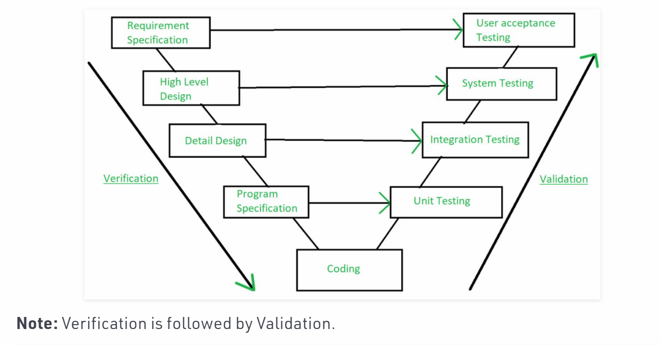

## Verification vs Validation: Key Difference

Here is the main difference between verification and validation testing:

## ****Example of verification and validation****

Now, let's take an example to explain verification and validation planning:

* In Software Engineering, consider the following specification for verification testing and validation testing,

**A clickable button with name Submet**

* Verification would check the design doc and correcting the spelling mistake.
* Otherwise, the development team will create a button like

[](https://cdn.guru99.com/images/blog/submet.png)

Example of Verification

* + So new specification is

**A clickable button with name Submit**

* Once the code is ready, Validation is done. A Validation test found –

[](https://cdn.guru99.com/images/blog/ButtonClick.gif)

Ex

example of Validation

* Owing to Validation testing, the development team will make the submit button clickable

----------------------------------------------------------------------------------------------

**Agile Methodology:**

Agile is a methodology followed across various project for project Development and Testing.

**Agile Methodology:**

Stake holders/Product owners / Business People:

Requirements to develop any product or software will be analysed at high level and start preparing Product Backlog. Imported Bug Fixes will also be included. **Product Owner** is responsible for this.

Let’s say we are in **sprint** **52:**

Sprint duration will be from 1 week to 4 weeks.

**3week sprint:** The User stories given need to be developed and tested within 3 weeks duration along with bug fixes.

**User Story 345**: **Christmas sales banners** need to be included in flip kart home page.

Description: As a customer I need feasibility to view the **Christmas sales** promotion on flip kart application home page as a banner

**Acceptance Criteria:**

The banner should contain the below information:

1.Sale should start on 22nd December to 28th December at 12 AM.

2. Santa image should appear

3. **Christmas sales** need to be displayed on the tree

4.duration need to be mentioned, service provider name needs to be mentioned.

5.hdfc Bank discount % and Axis bank discount % discounts/offer.

7.Shop now button should be displayed and should be enabled and when user select it, should navigate to offer details page

User Story points: 0,1,1,2,3,5,8,11,13,17 -> Follows Fibonacci series

8*8=64 hours of time is allocated to develop and test this banner **user story 345.**

**Development time: 48 hours**

**Testing team: 16 hours**

**sprint** **52:** 8 user **stories** are taken by dev team and testing.

**3-week sprint: 21 days -> 15 are working days**

**Per day 8 hours -> so for 15 days: 15 *8 =120 hours**

**6 developers: 6 *120 = 720 hours ->400 hours taken into consideration**

**3 testers: 3*120 =360 hours  ->200 hours taken into consideration**

**Total 1080 hours.**

**600 hours: Take this into consideration**

**Hours utilized: 64**

Sprint Planning: usually happens at beginning day of sprint.

Sprint Planning: Accepting 9 user stories.

**Sprint grooming**: takes place at beginning day of the sprint.

BA, Dev Team and Testing Team will be involved -> Analyze all the user stories accepted in Sprint 52.

Requirement Analysis need to be completed by 2nd day-> both dev team and testing team.

3rd day of sprint: Dev team need to start developing the user story and testing team need to start writing test cases.

**Scrum Calls / Daily Stand-up meetings**:(15 minutes) Scum Master will be leading this.

Each and every member (both dev team and testing team):

1.what we have done yesterday

2.what we are going to do today.

3.Any Impediment’s (blockages) for the work.

**Scrum Master:**

Us 1344: dev and team

Dev:

Test:

Impediment’s:

Us 1346: good

Us 1345: good

**Testers / QA Team:**

3rd Day, 4Th Day: Writing the test cases and get it reviewed by Peer Review or QA Lead.

Test cases can be in Excel Sheet or uploaded to **JIRA or HP ALM.**

Also Update the RTM (Requirement Traceability Matrix)

5th Day -> Test data need to prepared and make the environment ready.

2nd Week or 3rd Week: -> If any user Story code is deployed into Testing Environment (SIT, UAT), Start Testing the User Story and raise defects/bugs. Get them fixed by dev team and re-test the defects and close them.

**Exit Criteria**: When all the test cases (+ve and negative) are executed and all the defects are resolved and retested by QA Team. When integration of modules/flow is tested. When all the AC mentioned in User Story has been satisfied, then we can say exit criteria had been met and user story can be delivered.

**All the test data used for testing and test cases, test scripts including screen shots are stored in common location.**

**Demo to PO: date 27 April 5 :30 pm:**

**User Story information need to be open in JIRA.**

**Sprint Retrospective Meeting:** At the end of the sprint, we will have this meeting.

**Discuss about:**

1. What went Well
2. What can be improved (out of 9, we have delivered 7)
3. Any feedback or suggestions are welcome/acceptable.

**2 user stories will be added to product backlog**

**Burnt Down Chat:**

**JIRA:**

**Testing Activities:**

1. **Analysing User Story and writing test cases -> it is strike out which indicated that this activity is completed.**
2. **Preparing the test data.**
3. **Executing test cases**
4. **Defect Re-testing**
5. **Demo**

**-----------------------------------------------------------------------------------------**  
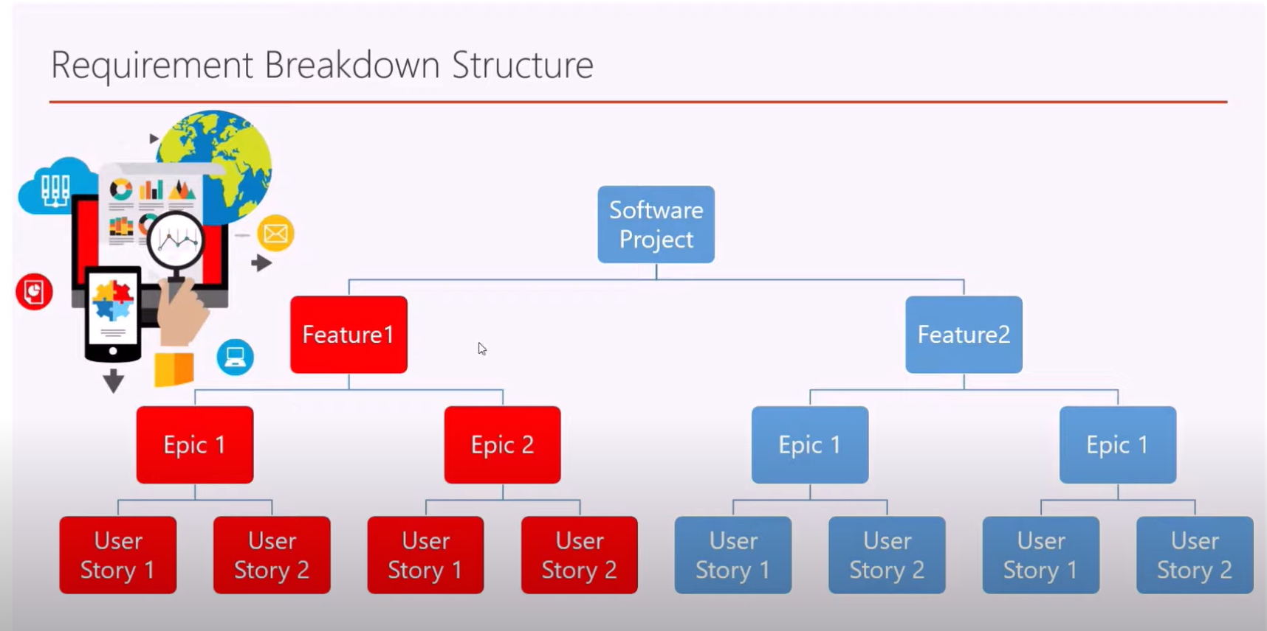

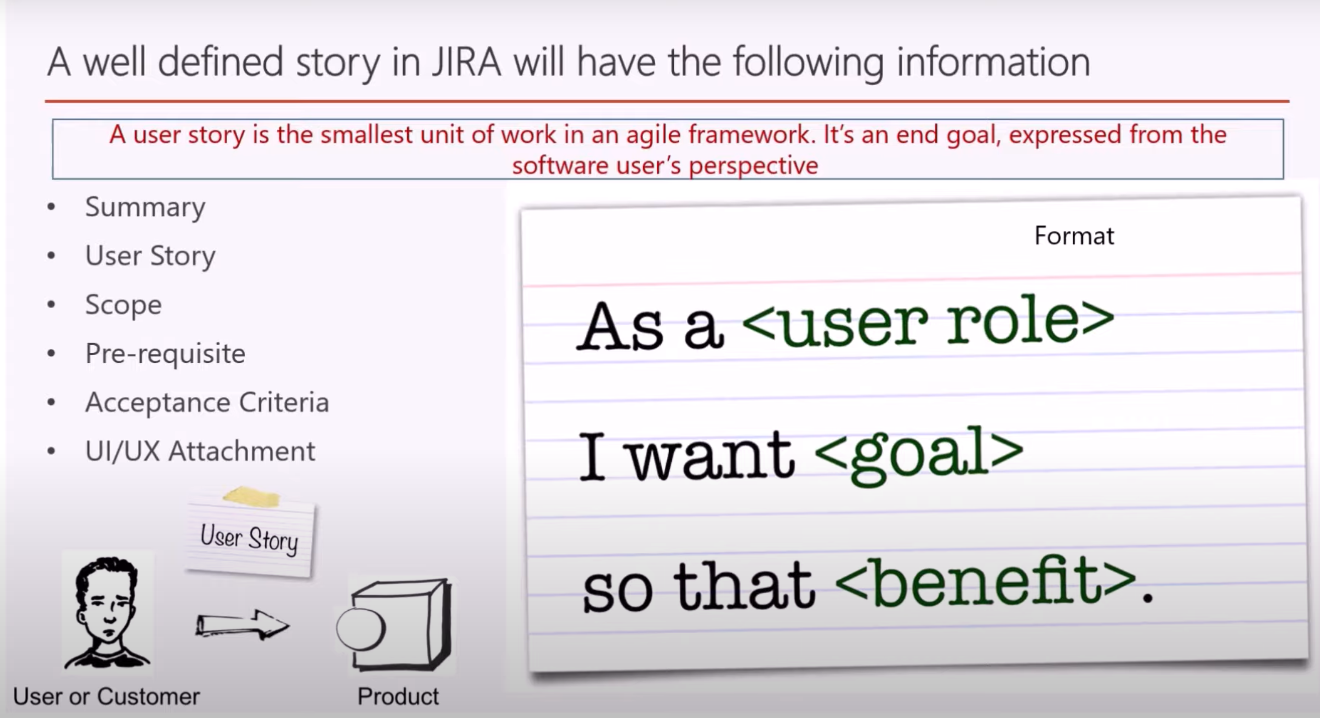

Refer :

<https://www.youtube.com/watch?v=XPqOqWw0d0c>

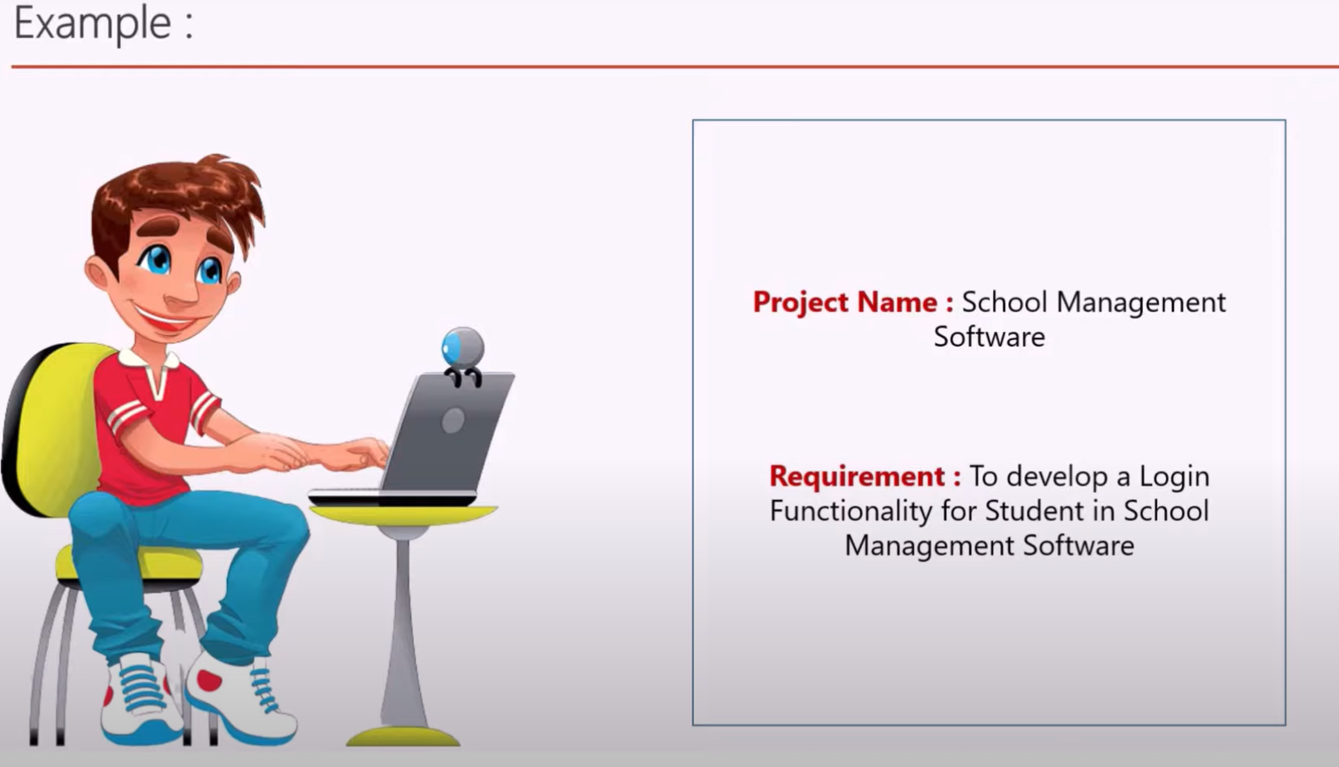

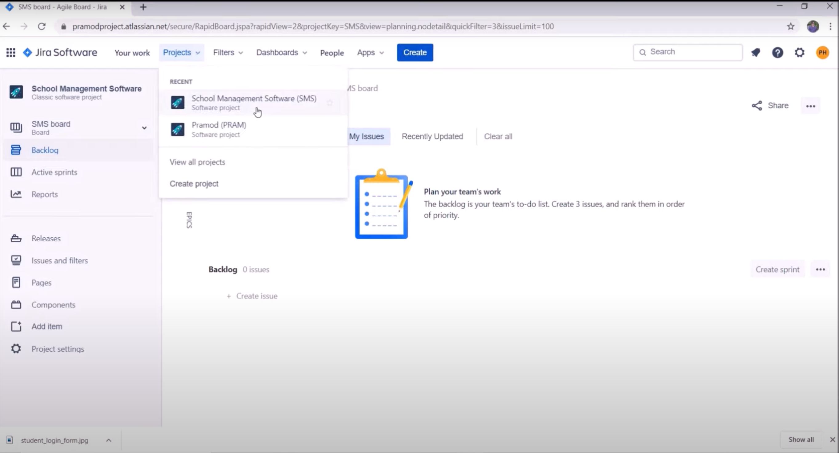

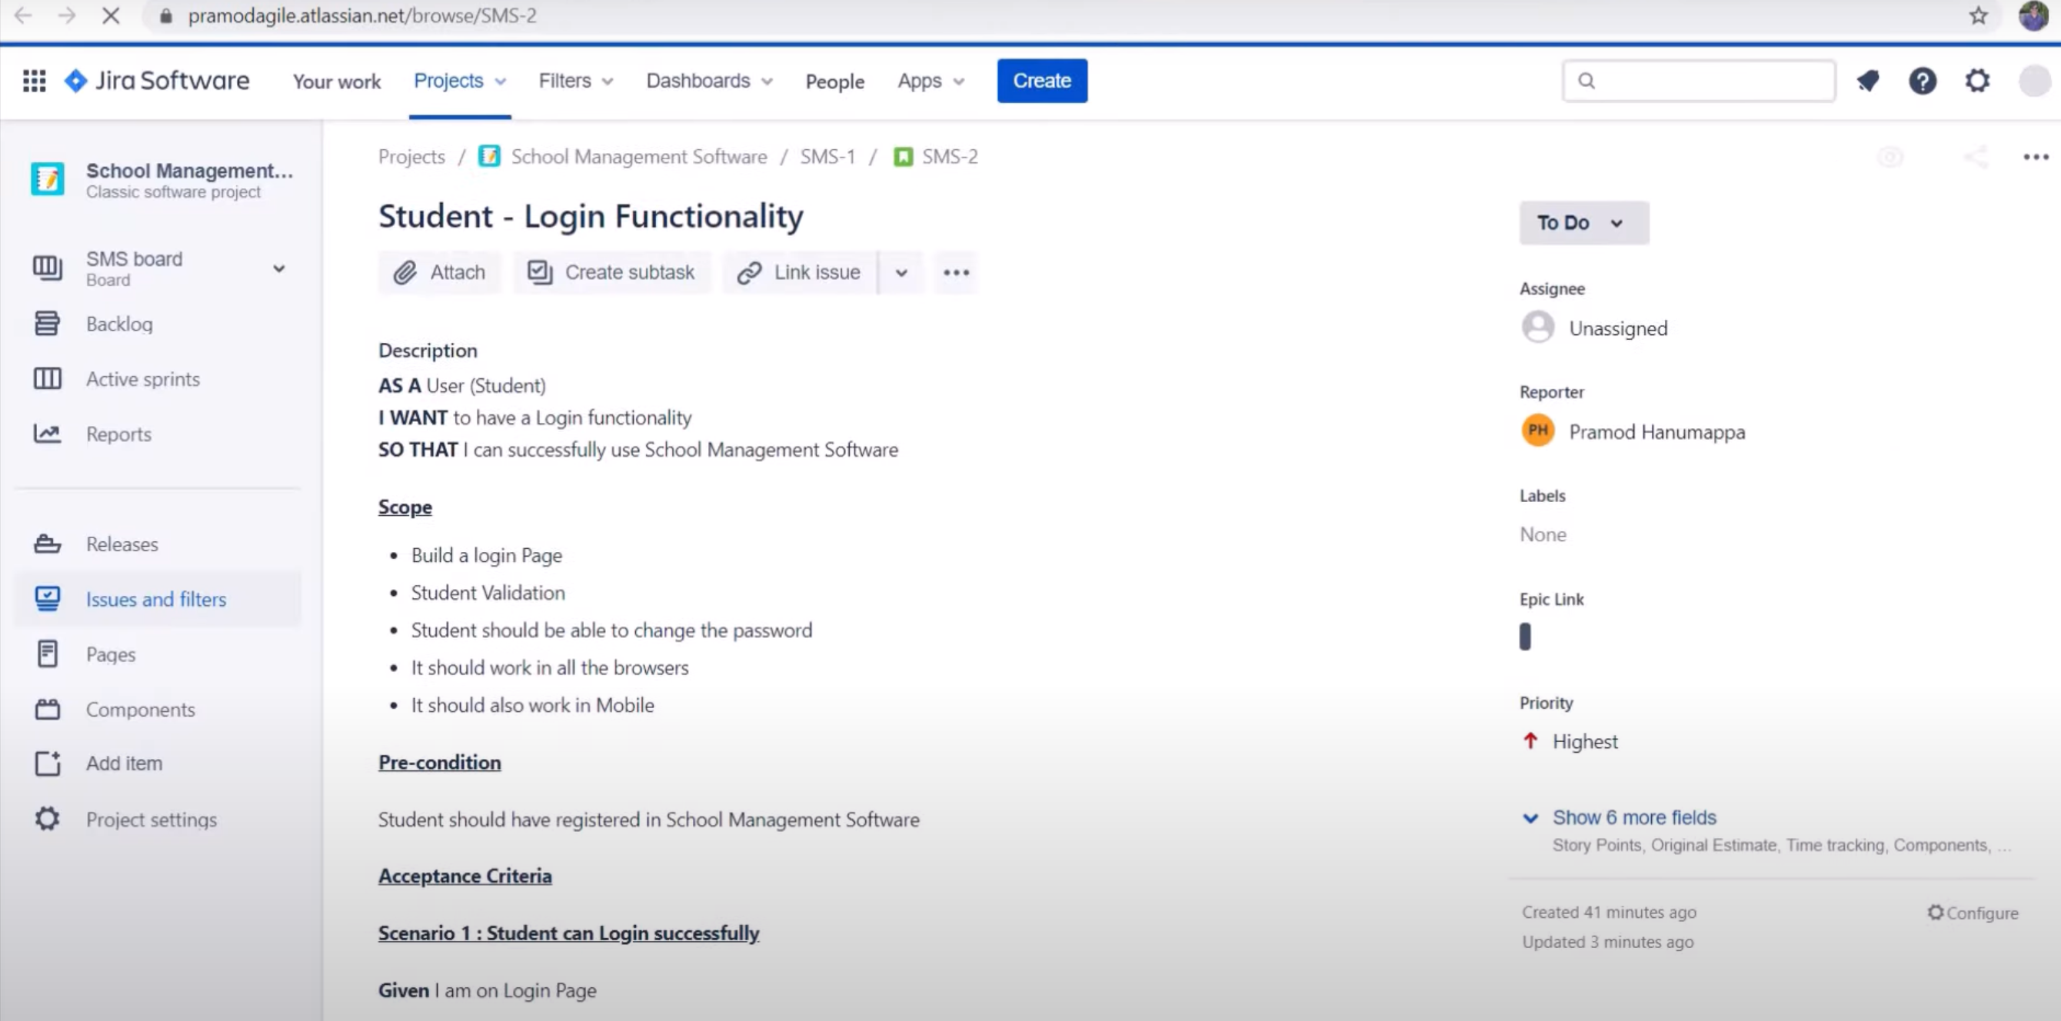

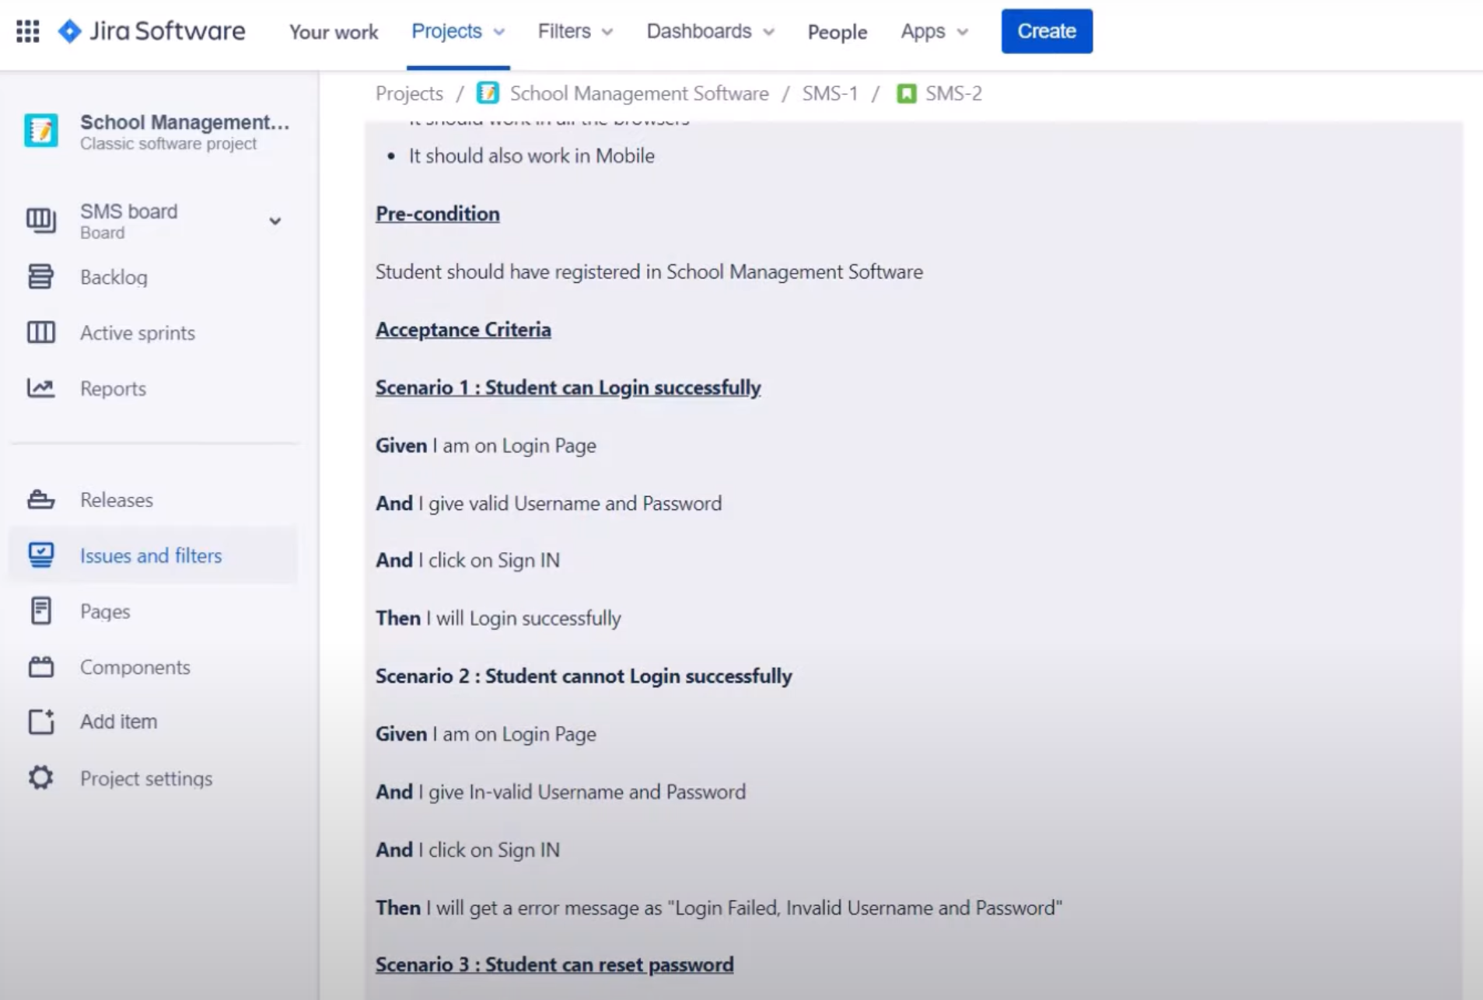

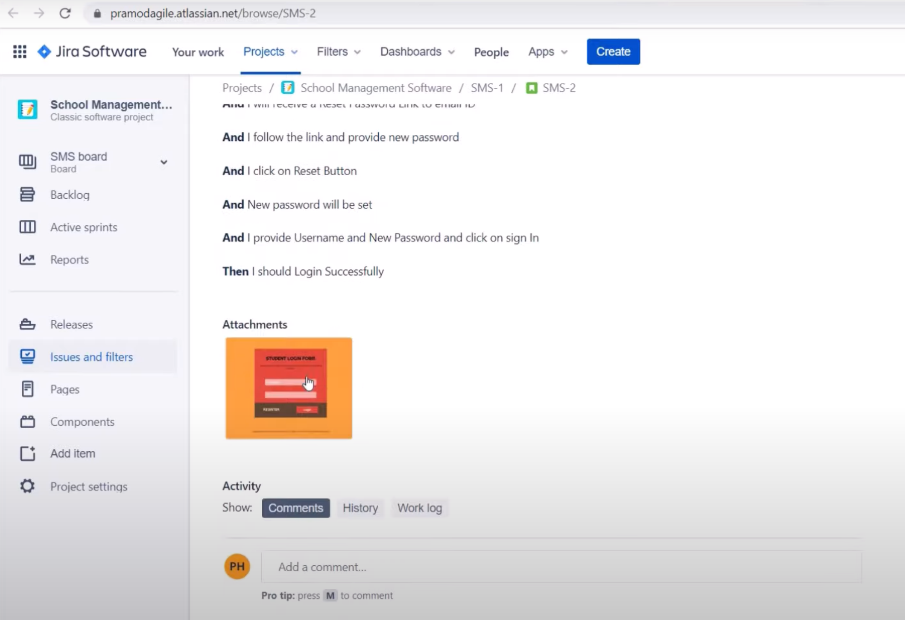

<https://www.youtube.com/watch?v=foWlWD__5m4>

<https://stormotion.io/blog/how-to-write-a-good-user-story-with-examples-templates/>

**Requirement Traceability Matrix:**

[**https://www.guru99.com/traceability-matrix.html**](https://www.guru99.com/traceability-matrix.html)

